SUPPLEMENTARY MATERIAL
This appendix collects supporting photographs, screenshots and simulation traces gathered during hardware bring-up and firmware development. This material documents the build process and is not required to assess the core results reported in Sections IV–VI.
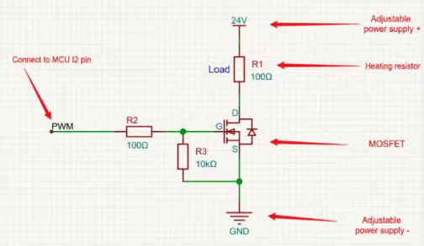
Fig. A1. Hand-drawn MOSFET heater driver schematic used during initial circuit design.
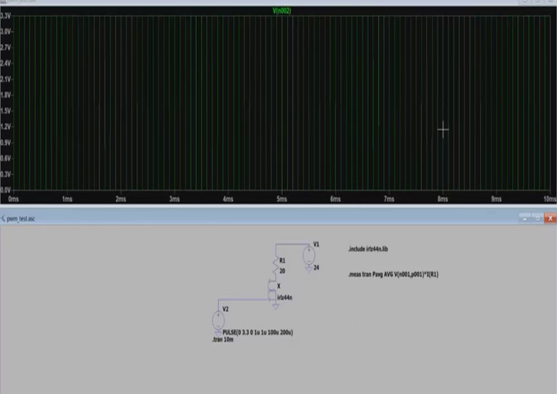
Fig. A2. LTspice transient simulation of the PWM gate-drive waveform at the MOSFET gate node.

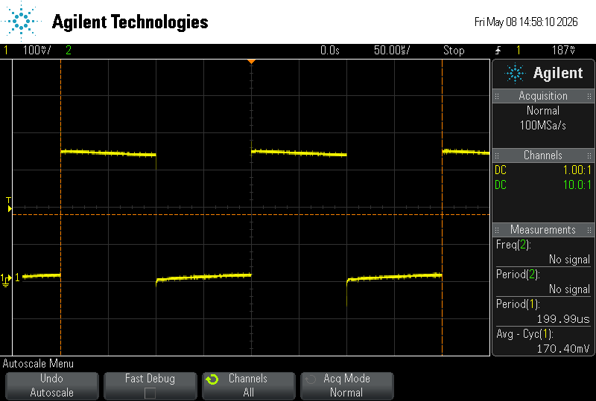
Fig. A4. Oscilloscope capture of the PWM gate-drive signal (initial bring-up).
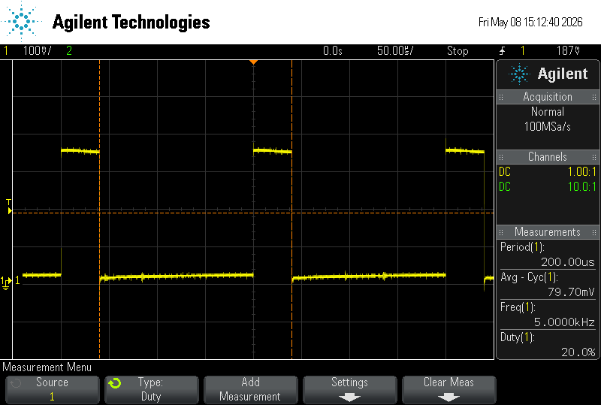
Fig. A5. Oscilloscope capture of the PWM signal at 20% duty cycle, 5 kHz.
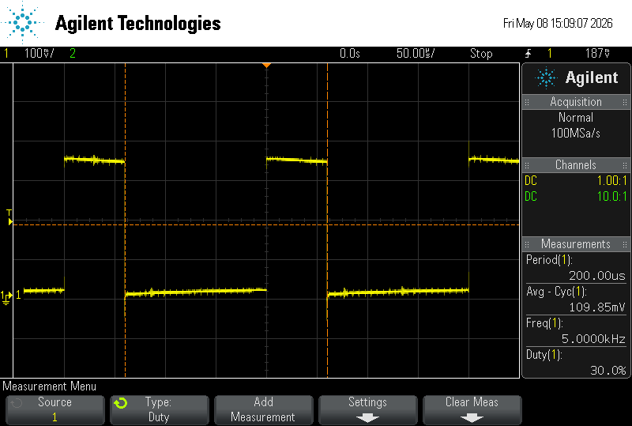
Fig. A6. Oscilloscope capture of the PWM signal at 30% duty cycle, 5 kHz.
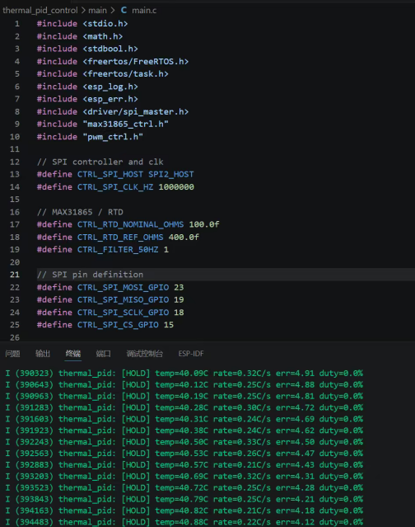
Fig. A7. Firmware source excerpt (main.c) and serial log showing the HOLD-state controller output during commissioning.
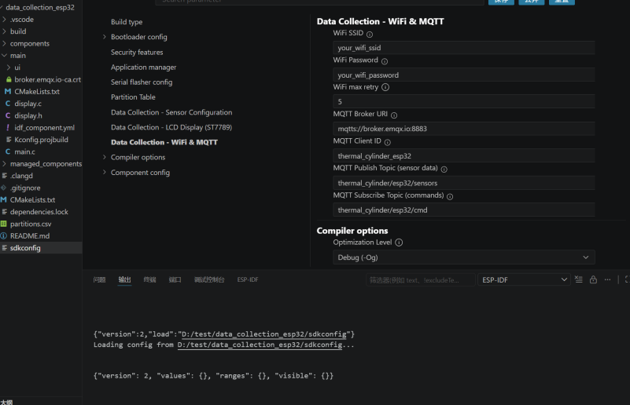
Fig. A8. ESP-IDF menuconfig screen showing the Wi-Fi/MQTT Kconfig options used to configure the rig without editing source code.
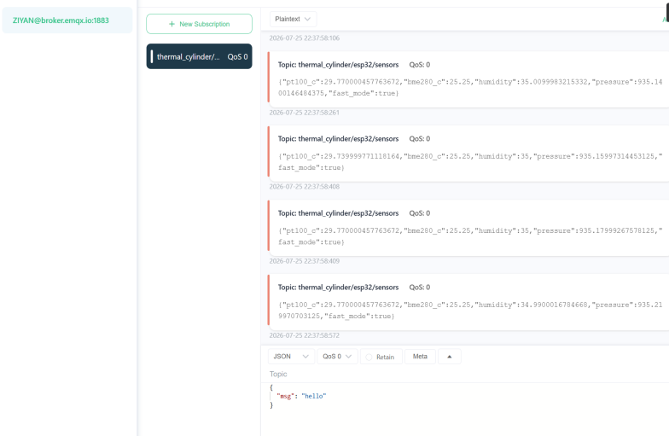
Fig. A9. MQTT client view of live JSON sensor data published on the sensors topic.
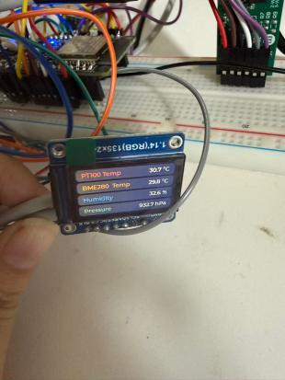
Fig. A10. Local ST7789 display showing live PT100 temperature, BME280 temperature, humidity and pressure readings on the assembled rig.
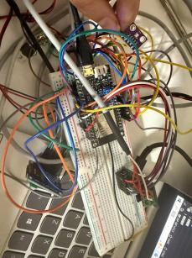
Fig. A11. Hardware system.
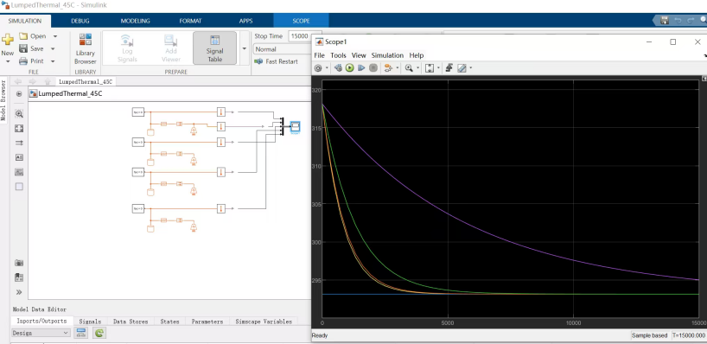
Fig. A12. Simulink model structure showing the four parallel lumped-thermal-capacitance branches used in the cross-check simulation.
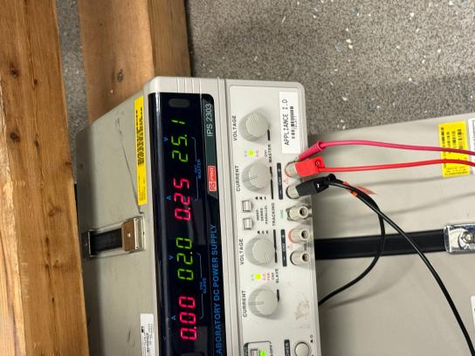
Fig. A13. Using power supply in the lab.

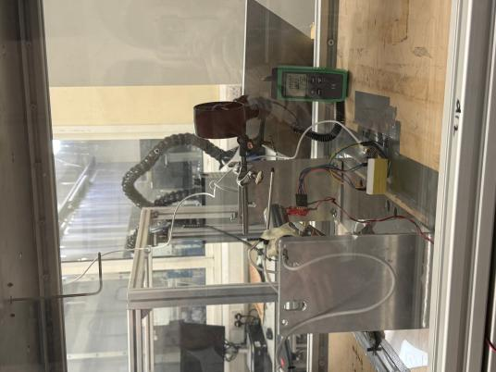
Fig. A14.Experiments conducted in the wind tunnel laboratory .

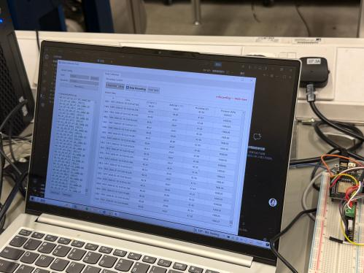
Fig. A15. Running data on a computer.

